Logistics, supply chain and value chain

DIGIROM is a multi-service provider such as internet, television and telephone. For those three services we need different supplies like internet routers, TV antennas, cables, tools.

***Supply network***

Upstream Downstream

First tier suppliers First tier customers

Internet customer

TP-LINK   
internet router

Buy side Inside Sell side

Supply chain management

Telephone

customers

TV

customers

Mohu Leaf Metro HDTV  
TV antennas

ATLP

telephones

Cablx

cables

Company

***The company’s value chain***

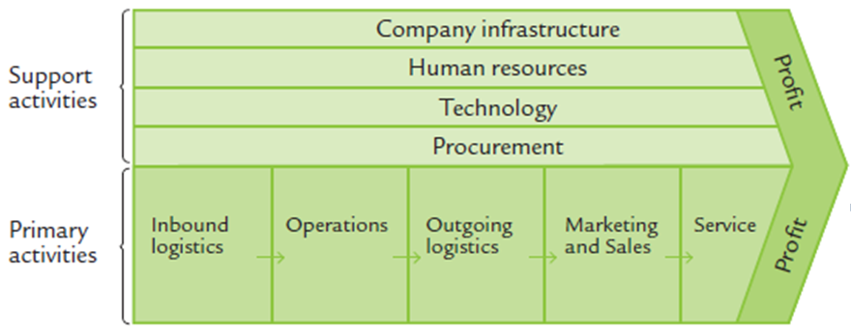

Support activities

For the company infrastructure we have a headquarter in Vatra Dornei and four cars for work field. As far as the human resources are concerned there are twenty employees, four of them are doing office work, fifteen specialists doing the field work and the manager. The company is using the latest technology available on the market enabling them to provide high quality 4k television, ultra fast internet and HD voice telephone services.

Primary activities

The inbound logistics determine the activity of receiving and storing supplies for further use. Every internet router is from “TP-LINK“, the TV antennas are from “Mohu Leaf Metro HDTV”, the telephones from ATLP and the cables from Cablx. Because the supplies don’t take much space, we store them at our headquarters. As for the outgoing logistics we can transport the needed supplies towards our customers with our cars. The manager is taking care of the marketing and sales, advertising on local television, newspapers, short ads on radio and banners for the internet. We provide quality services at very competitive prices. We offer flexible subscriptions suitable for every customer.

# Bibliography

Supply network. Source: Harrison and van Hoek (2008 : 9)

The company’s value chain. Source Porter (1985)